**Gilteritinib 30 min (all reps) - Significant change of mean FDR = 0.2**

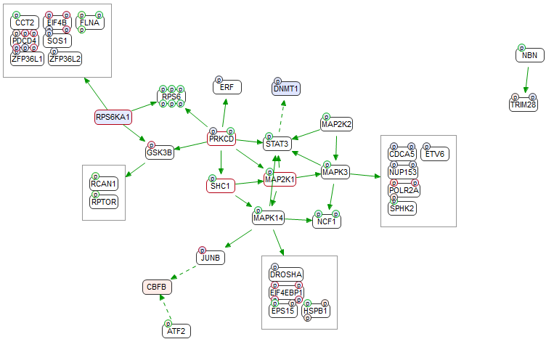

**Gilteritinib 180 min (all reps) - Significant change of mean FDR = 0.2**

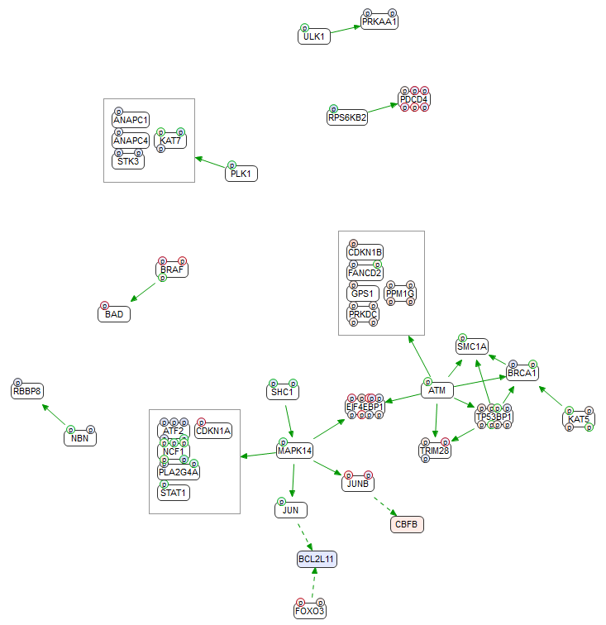

**DMSO 0 min vs Gilteritinib 30 min - Fold mean of change FDR = 2.5**

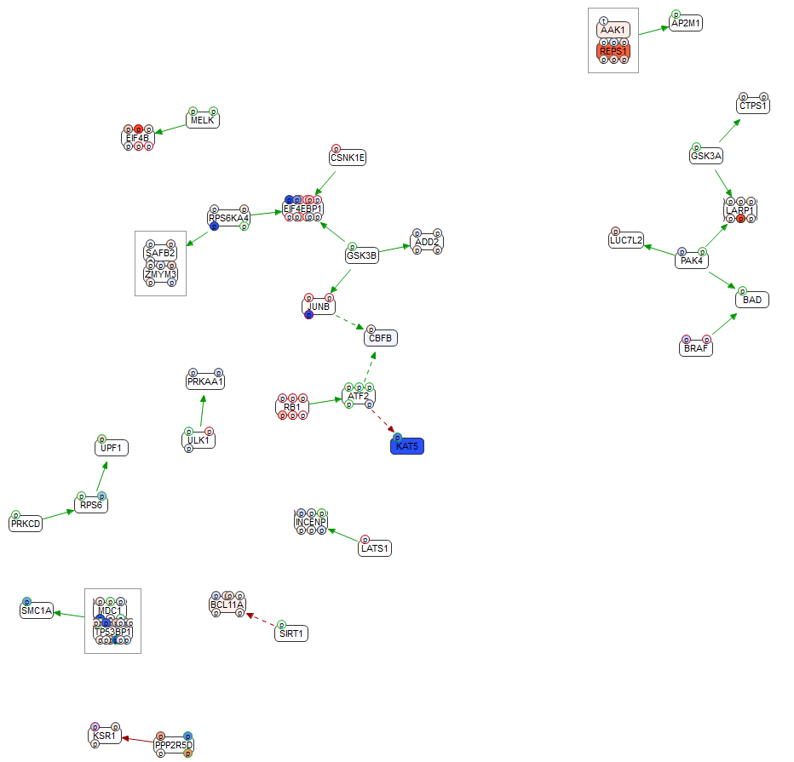

**DMSO 30 min vs Gilteritinib 30 min - Fold mean of change FDR = 2.5**

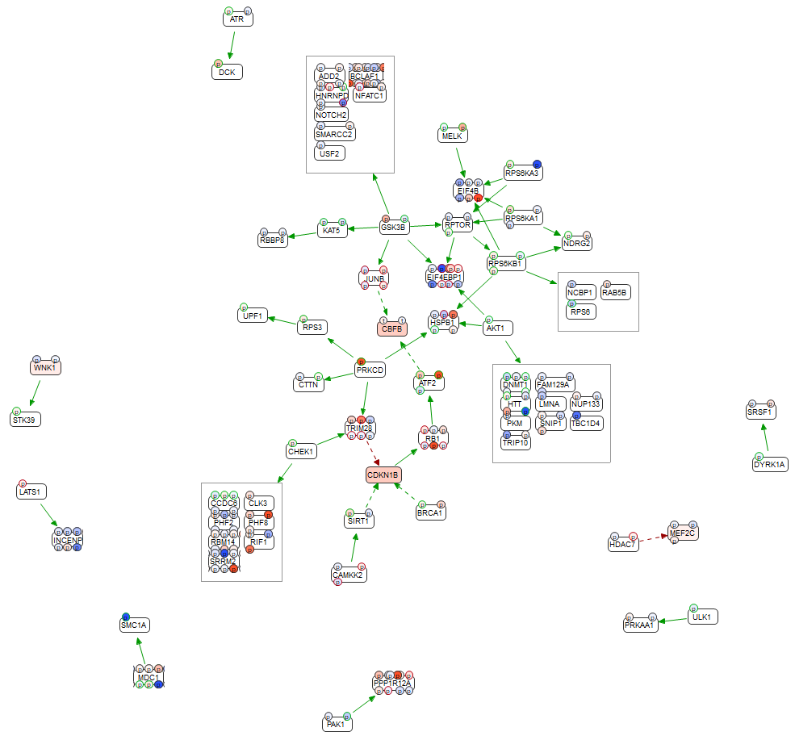

**DMSO 0 min vs Gilteritinib 180 min - Fold mean of change FDR = 2.5**

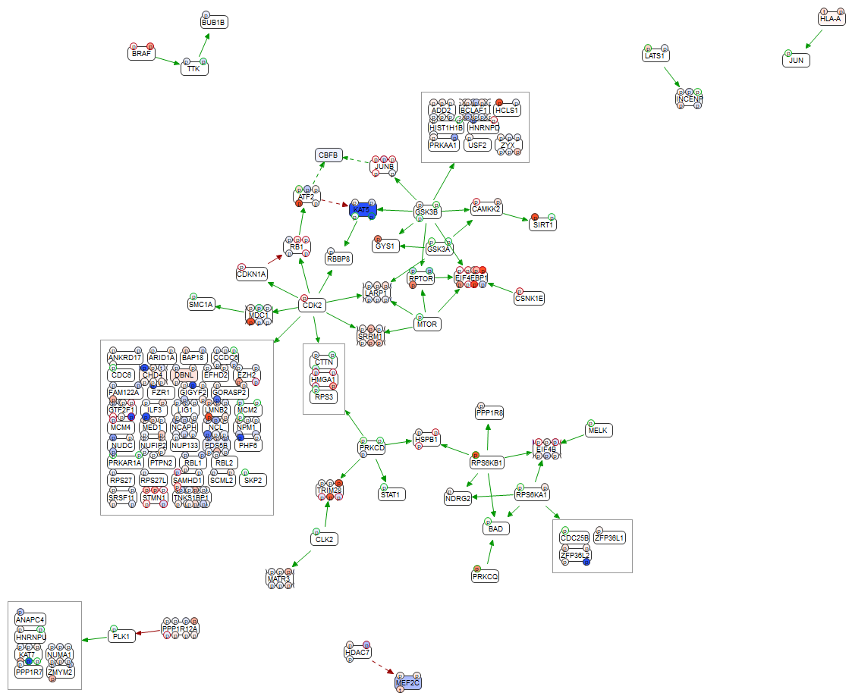

**DMSO 180 min vs Gilteritinib 180 min - Fold mean of change FDR = 2.5**

